


Application to become a Wetland Bird Survey Local Organiser

Surname  Title | First name(s)
Address | Tel.no.  Is this home/work/mobile?
Address | E-mail address
Address | WeBS region applied for
Address | How long resident in the above region | Are you a BTO member and if so, for how long?
WeBS experience – Please tell us how long you have been taking part, and any WeBS sectors that you currently or have previously counted

Current & previous wildlife involvement, including other BTO surveys undertaken (if any)

What experience do you have that might be relevant to this post? This could include organising skills, computer experience, voluntary experience, training courses, social media etc.

How in depth is your knowledge of the local waterbird avifauna and wetland sites within the WeBS region? Would you need any help with verifying counts?

Please let us know about your membership of wildlife societies and Bird Clubs and any roles or involvement you have with them. Do you have good local contacts to support and increase WeBS coverage in the region?

Are there any other comments you wish to make that are relevant to this position?

For the purposes of the Data Protection Act, the Data Controller is the Director of Services at the BTO. The information contained within this application will be held in a secure file at BTO HQ.

The foregoing is a true and accurate record

Signed………………………………………………………………Date………………………………………………….

Please return this application form to:
Gill Birtles, WeBS Office, BTO, The Nunnery, Thetford, Norfolk, IP24 2PU.
Email: webs@bto.org

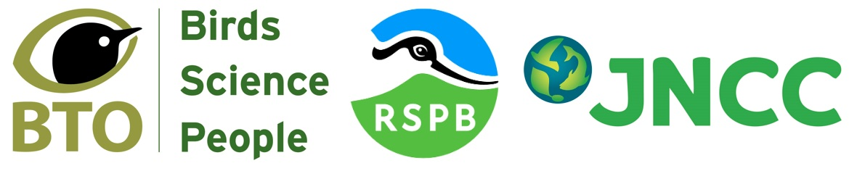
The Wetland Bird Survey (WeBS) is the monitoring scheme for non-breeding waterbirds in the UK which aims to provide the principal data for the conservation of their populations and wetland habitats.
WeBS is a partnership jointly funded by the BTO, RSPB and JNCC, with fieldwork conducted by volunteers. www.bto.org/webs
https://www.bto.org/our-science/projects/wetland-bird-survey/taking-part/become-webs-local-organiser

